Preparing for a Chalk Art Event

Thank you for inviting us to minister alongside you. May these materials bless in your preparation. We endeavor to Engage all ages with the Gospel, Enrich believers with God's Word, and Encourage leaders in the church during our time in ministry with you. Check www.Facebook.com/ChalkEvangelist/events. Please proof these materials and return the confirmation page at your earliest convenience.

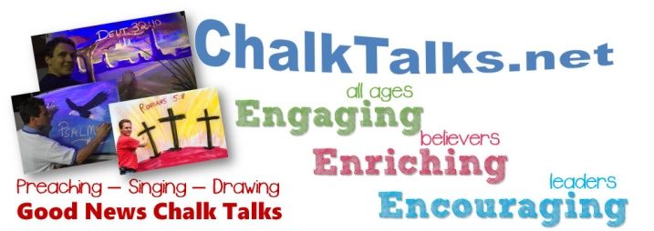

What will it cost for Dwight to come?
Dwight and his family live by faith with their livelihood coming from love-offerings from the evangelism ministry. They invite churches to help with their expenses for a meeting, as much as you are able, in a separate, preferably advanced, reimbursement check for travel at the current IRS Standard Mileage Rate, allowances for meals during travel, and for art supplies/equipment (see Engagement Confirmation sheet for details). In addition to expenses, the Haynes Family is content with a love offering and/or honorarium appropriate to the time and type of ministry provided.
Finances should never be an obstacle to ministry, but rather an opportunity for God to glorify Himself as Jehovah Jireh—Our Provider. Customize the Engagement Confirmation for your needs.

Facility or Auditorium:
- Space for our 4 ft. display/resource table near the service entry or greeting area.
- If possible, clear a central area of the stage at least 6'deep by 8' wide for the easel.
- Provide One standard XLR, 3-connector mic cable to an open channel.
- One electrical outlet within 10 feet of stage.

Accommodations and Meals:
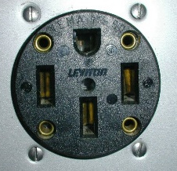
Dwight travels with his family. Accommodations should be private and appropriate for home-school. If they bring their Motorhome, if possible
provide a 50A, 220V outside outlet, which
is a standard kitchen range outlet. They
carry heavy-duty ext. cords and adapters
for any 120V or 220v outlets. Access to water
and sewer is welcome, but not necessary.
Please discuss meals ahead of time. Church groups may wish to sponsor meals for added fellowship.
We want to share in ministry with you, so feel free to discuss your needs with us as well.
How does the church prepare?
- Get excited about it!
- Pray for God’s power on the meeting & for your personal receptivity to God’s Word and Spirit.
- Use the provided materials for promotion:
  - 4 wks prior, use first ½ pg. bulletin insert (front intro & back bio) and put out full-page posters for members to post locally.
  - 3 wks prior, use second half-page bulletin insert ( Invite & Gospel), post on website, release to newspaper calendar of events.
  - 2 wks prior, put “CHALKTALKS - Dates - times” on the marquee sign.
  - Week of Service: Use third bulletin insert.
- Invite your friends, neighbors, family, & church community to see the Chalk Talks using signs, cards, posters, e-mail, FaceBook, and texts.
- Spread the Word that the chalk-drawing will be given away at the service to the one who either INVITES or BRINGS the most visitors, and let’s try to get many souls to see & hear God’s Word!
- Pastors, plan ahead to spend time with Dwight and his family while they are in town.

What to expect in a Chalk-Art Service:
Arrival: The Haynes family will arrive at the church about 45 minutes prior to the start time of the first service to set up equipment and test the sound.
Service: The chalk-art, music, and preaching takes 35-40 minutes. Dwight and Ann provide special music. You may plan the normal opening worship service and introduce the Haynes Family as serving in full-time missionary evangelism, encouraging individuals to learn more by visiting the display table.
Dwight will introduce the message and invite Ann to sing with him. He will begin drawing with musical background and finish drawing as he preaches. Dwight will close with a prayer and have everyone to stand as the pastor comes to close the service.
Offering: Love offerings give everyone an opportunity to participate in God’s provision for the Haynes Family. Also, please consider this family for regular missions support.

Ministry Engagement Confirmation
"Serving by Faith...
Supported by Believers."
Missionaries Dwight & Ann Haynes ▪ 4582 Miller Lane ▪ Pulaski, VA 24301 ▪ 540.230.5782 ▪ Dwight @ ChalkTalks.net

I, PastorName and ChurchName, located at ChurchRd, ChurchTown, CHURCHST, confirm that these promotional details are correct and engage Rev. Dwight Haynes to minister at times on Dates for a special service (If possible, please list event on website and social media pages.)
The best phone number to reach me is (540) 230-5782 or __________________________________.
Alternate contact's name __________________________& cell number ______________________.

Travel Arrangements considered as follows:*
We can participate in expenses for the Haynes' OR We can provide a portion of the Haynes'
as estimated below: needs or a budgeted amount as follows:
Mileage: 200rt miles x 0.58smr =$ 115.00 ____________________________________
Supplies: $35/drawing x 1 =$ 35.00 ____________________________________
Meals: $50 travel meal(s) =$ 50.00 ____________________________________
Lodging: RV 200rt miles x 0.50 =$ 100.00
Total Expense Check from church =$ 300.00
*Whatever the church would like to do financially is always acceptable with the Haynes family. We do not charge for ministry, but it does help us to plan for travels ahead of time when a congregation lets us know their intentions. Thank you.
We plan to receive a free-will love offering at the time(s) of each service in which Rev. Haynes presents his ministry during this engagement.
We plan to share the following budgeted honorarium for the Haynes family: ______ ____.
We will allow Rev. Haynes to distribute ministry literature and provide resource materials for donations on a display table to be set up in an area visible and accessible to all attendees. Or, we suggest _________________________________________________________________________________.
Ministry Details:
Occasion/Theme: SPECIAL SERVICE Gender/Age to be addressed: All ___
Seating Capacity: ________________ Expected Attendance: _______________
Are there other invited special speakers? _________ If yes, list their name(s)/date(s)/time(s): ___________________________________________________________________________________
Are there any special events before or after the service that you would like Rev. Haynes and his family to attend (i.e.: meal, class, prayer meeting, etc.) ? __________ If yes, explain:____________________

Confirmation and Notification:
Rev. Haynes will confirm this engagement upon receipt of this form. Please notify Evangelist Dwight Haynes of any changes in plans. After confirmation, if the coordinator cancels within 30 days of the engagement, any advance expenses will serve as a love-offering to the Haynes Family to assist them in their livelihood and ministry as full-time missionaries to America. Should Rev. Haynes cancel at anytime, the entire amount of the expense check will be refunded within 30 days of his notice of cancellation.

Please mail (or e-mail) this confirmation (and advance expense check, if possible) to
Rev. Dwight Haynes, 4582 Miller Lane, Pulaski, VA 24301.
For any questions, please call 540.230.5782 or e-mail Dwight @ ChalkTalks.net.
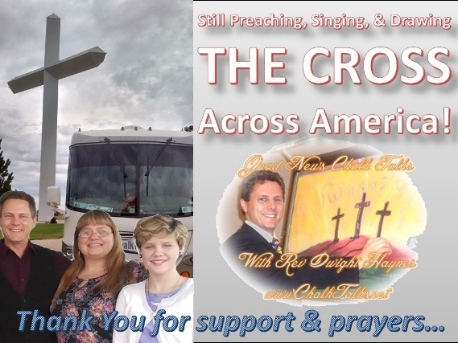
Rev. Dwight Haynes
Evangelist & Gospel Chalk-Artist
Preaching
Drawing
Singing
God’s Good News!
Rev. Dwight Haynes is a master chalk-artist and biblical evangelist. He holds a Master’s degree in Religious Education from Liberty University and a Bachelor of Theology degree, with youth and music minors, from Piedmont Bible College & International University. He and his Wife, Ann, sing beautifully together and travel with their family wherever God opens a door to minister.
Dwight has utilized God’s ministry gifts since 1994 as a Gospel Chalk-Artist, serving as a home-missionary to nursing & retirement homes, pastoring churches in Virginia and North Carolina, and as an international missionary-evangelist. He has travelled with his talents to minister in many of the United States of America and in England, Scotland, and Southeast Asia. His wife and two beautiful daughters serve alongside him to inspire and relate God’s love through creative evangelism.
Having served as a Christian school administrator, Brother Haynes and his wife parent and home school their children with biblical conviction and enjoy ministry and family together. Dwight is the co-founder and a consulting director of Life Development International, a missionary-training ministry based in Southeast Asia.

540.230.5782 Dwight @ ChalkTalks.net

Chalk Talks at ChurchName
churchrd, churchtown, churchst
times on dates
See, Hear, & Experience
A blank, gray canvas
Transform into a beautiful
Illustration of Scripture!

Dear Pastor Pastorname, Congregation & Guests,
I look forward to sharing in Worship & Fellowship with you. Please pray for God’s power in our time together. Ask the Lord to use you to introduce and promote this ministry to others in your life who need to draw nearer to Christ.
Thank you for inviting us to come share in this special service. Get excited about it! Call, text, e-mail, and like us on www.FaceBook.com/ChalkEvangelist and share this meeting with your friends. May God to bless YOU with His Word and draw men, women, boys, and girls to Christ for His Glory!
Joyfully Yours in Christ,

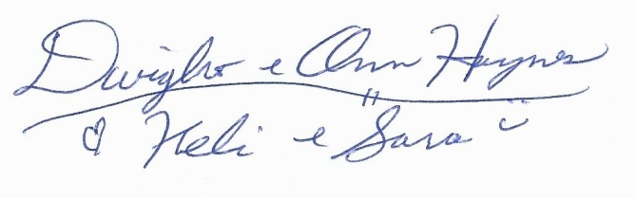
4582 Miller Lane, Pulaski, VA 24301
540.230.5782 Dwight @ ChalkTalks.net
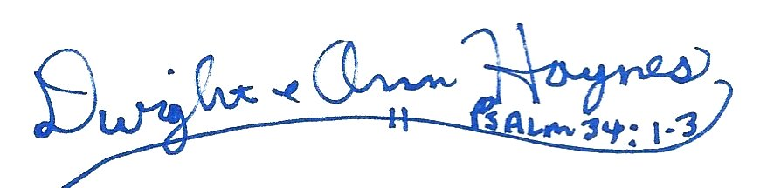
SPECIAL SERVICE
ChurchName

Times
Dates

Pastor pastorname
& congregation
invite you to
Churchname
Churchrd
Churchtown, Churchst

For More Information, Contact
Dwight@ChalkTalks.net
or CALL (540) 230-5782

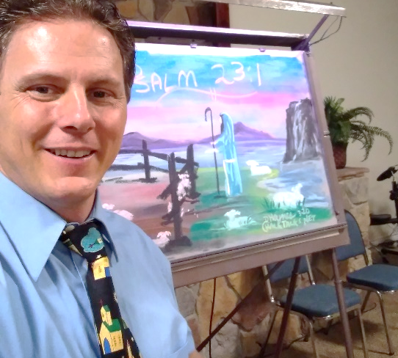
Hi Friend, this is your special invitation…
See, Hear, and experience
a Blank, Gray
Canvas
transform into a beautiful
illustration of Scripture!
____

EVANGELIST
Dwight Haynes
& Family
________

ChalkTalks.net

Wow! Colors-n-chalks, BleNdiNG & s-k-e-t-c-h-I-n-g until, finally, a blank, gray canvas has been transformed into an inspiring window of breath-taking scenery and beautiful imagery. Live Chalk Art is AMAZING! It Catches Your Eye and Grabs Your Interest? Why???
Why Chalk?
…because creation fascinates every created being.
Whose Image?
Ever wondered how you were created? Who designed you to be a thinking, living and very wonderfully made human being? The Bible tells us that "God created man in His own image… male and female created He them." (Genesis 1:27) Psalm 139:14 praises God, "for I am fearfully and wonderfully made."

We love to enjoy that which we create ourselves. God loves you, "but your iniquities [sins] have separated between you and your God, and your sins have hid his face from you, that he will not hear." (Isaiah 59:3)
GOOD NEWS
is found in Romans 5:8, "But God commendeth his love toward us in that while we were yet sinners, Christ died for us." So, YES, we can once again know our creator, God, and spend all eternity in His presence in heaven. "If thou shalt confess with thy mouth the Lord Jesus, and shalt believe in thine heart that God hath raised him from the dead, thou shalt be saved." (Romans 10:9)
Have you accepted God’s offer of relationship with Him through faith in Jesus Christ? What better time than the present to say: “God have mercy on me a sinner…I believe and receive Jesus as my Savior and desire to follow Him as Lord of my life.”

Joy in Christ, Rev. Dwight D. Haynes, Chalk-Art Evangelist

WIN THE ART:

Keep track of how many people you invite each service!
Keep track of how many visitors you have attend!
WE WELCOME IN TODAY’S WORSHIP

Hi Friend, We welcome you to worship today.
churchname
churchrd, churchtown, churchst
times, dates
Wow! Colors-n-chalks, BleNdiNG & s-k-e-t-c-h-I-n-g until, finally, a blank, gray canvas has been transformed into an inspiring window of breath-taking scenery and beautiful imagery. Live Chalk Art is AMAZING! It Catches Your Eye and Grabs Your Interest? Why???
Why Chalk?
…because creation fascinates every created being.
Whose Image?
Ever wondered how you were created? Who designed you to be a thinking, living and very wonderfully made human being? The Bible tells us that "God created man in His own image… male and female created He them." (Genesis 1:27) Psalm 139:14 praises God, "for I am fearfully and wonderfully made."

We love to enjoy that which we create ourselves. God loves you, "but your iniquities [sins] have separated between you and your God, and your sins have hid his face from you, that he will not hear." (Isaiah 59:3)
GOOD NEWS
is found in Romans 5:8, "But God commendeth his love toward us in that while we were yet sinners, Christ died for us." So, YES, we can once again know our creator, God, and spend all eternity in His presence in heaven. "If thou shalt confess with thy mouth the Lord Jesus, and shalt believe in thine heart that God hath raised him from the dead, thou shalt be saved." (Romans 10:9)
Have you accepted God’s offer of relationship with Him through faith in Jesus Christ? What better time than the present to say: “God have mercy on me a sinner…I believe and receive Jesus as my Savior and desire to follow Him as Lord of my life.”
@
Joy in Christ, Rev. Dwight D. Haynes, Chalk-Art Evangelist

WIN THE ART:

Keep track of how many people you invite each service!
Keep track of how many visitors you have attend!

SPECIAL SERVICE
See, Hear, and experience
a Blank, Gray
Canvas
transform into a beautiful
illustration of Scripture!
____

EVANGELIST
Dwight Haynes
____

www.ChalkTalks.net

ChurchName

Times
Dates

Pastor Pastorname
& congregation
invite you to
Churchname
Churchrd
Churchtown, Churchst

For More Information, Contact
Dwight@ChalkTalks.net
or CALL (540) 230-5782
Rev. Dwight D. Haynes, Evangelist 4582 Miller Lane, Pulaski, VA 24301 540.230.5782 Dwight @ ChalkTalks.net

PRESS RELEASE

Date of Release: Run through the two(2) weeks prior to Dates

Contact/Sender: PastorName, Dwight@ChalkTalks.net, (540) 230-5782

ChurchName invites everyone to our Special Service featuring Chalk Art Evangelist, Rev. Dwight Haynes, and his family. See, hear, and experience Scripture come alive with Bible Chalk Talks at ChurchRd, ChurchTown, CHURCHST, at times on Dates. This unique ministry will feature joyous and refreshing Christian music by Dwight and his Wife Ann Haynes, an encouraging Bible message beautifully illustrated on a large canvas in full-color along with amazing black-light effects. For more information about the Good News Chalk Talks and this service, phone (540) 230-5782, or read more online at www.ChalkTalks.net.

Biographical Sketch:
Rev. Dwight Haynes is a master chalk-artist and biblical evangelist.
He holds a Master’s degree in Religious Education from Liberty University and a Bachelor of Theology degree, with youth and music minors, from Piedmont International University. He and his Wife, Ann, sing beautifully together and travel with their family wherever God opens doors to minister.
Dwight has utilized God’s ministry gifts since 1994 as a Gospel Chalk-Artist, serving as a home-missionary to nursing & retirement homes, pastoring churches in Virginia and North Carolina, and as an international missionary-evangelist. He has travelled with his talents to minister in many of the United States of America and in England, Scotland, and Southeast Asia. His wife and family serve alongside him to inspire and relate God’s love through creative evangelism.
Having served as a Christian school administrator, Brother Haynes and his wife parent and home school their children with biblical conviction and enjoy ministry and family together. Dwight is the co-founder and a consulting director of Life Development International, a missionary-training ministry based in Southeast Asia.

